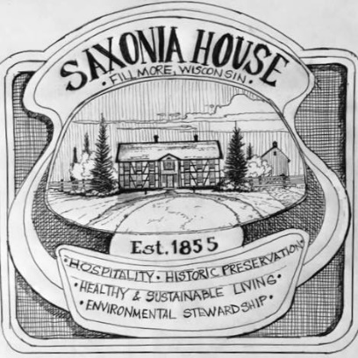
Friends of Saxonia House, Inc.
F.O.S.H. Board Meeting
Nov. 6, 2023
5:00 PM, ZOOM Platform
Minutes of Board Meeting

- Call Meeting to order: Attendees were Alan Pape, Ed Ritger, Greg Zahn, Rhonda Hare, Jim Dieringer at 5:11 pm. Alison Witt-Janssen joined at 5:45 and Fred Klessig joined at 6:04.
- Approval of September 11th, 2023 minutes: Greg motioned to approve and Ed seconded. These minutes are posted on the website.
- Treasurer’s Report: $15,000 CD matures in 3 weeks. There is $2,888.37 in checking and $857 in Flipcause. Portajohn is picked up and is paid. Property tax will be due. Now that we have more events, Ed is willing to do the work to apply for the property tax exemption, due in March, and he will present it to the Board for approval. Rhonda motioned and Jim seconded to accept the Treasurer’s report. Discussion followed as to whether or not to renew the CD. Greg advised to move this $15,000 to the checking account for use this coming year. Plus, the availability of cash will be favorable for grant applications. Greg motioned to liquidate the CD and put it in checking and Ed seconded.
Other: Since our Treasurer, Greg, has moved out of state, Ed motioned that Secretary Rhonda Hare will be temporarily authorized to deposit all incoming checks to the local Johnson Bank checking account. Jim seconded it. Ed also motioned and Jim seconded that the mailing address for Friends of Saxonia House, Inc will be changed to Rhonda Hare’s mailing address at 268 Hwy H Fredonia WI 53021 Greg will change this with the post office and Rhonda will change it on the website.
- Membership: Alison sent a report which shows 36 paid members. She is planning on sending out a letter with news of the year and reminders for coming year. Among the many new members, Jon Scott is a new member who is showing a lot of dedication and a knack for finance, who can be a great help for Alan. Another new member, Richard Otto Wiegand, is an author with lots of interest in local history.
- Special Events: Rhonda and Alison are planning a slide show of Oktoberfest for the annual meeting program. The date for the annual meeting was chosen as Monday January 8, 2024. All 2024 work days and Oktoberfest should be published at this meeting, or at least an outline with possible dates. Greg, Rhonda, and Alison are going to be the Events Committee and they will correspond about it getting the word out for the annual update.
- Development Report: Alan began revising the preliminary Business and Marketing Plan, he sent out seven plans and three of the advisers responded thus far. This is lots of work but he is happy to do it. Alan’s success with the preliminary grant from the Kohler Company and Kohler Foundation for $42,500 to be used for the log house/development of exhibits will give us a good chance for future grants from them. We will be preparing a major grant application for the Ruth Foundation for the Arts.
- Old Business:
- Scott and Fred patched up the roof of the poultry barn to protect it for winter. We are hoping to call this the “Welcome Barn”, and Alan sent a new sketch to show what it could look like. Looking at possible Kern family grant for this project. Ed Ritger has previously made an offer to donate a solar power system for this building.
- Next year’s volunteer project for Work Days will include cleaning up our John Klessig dairy barn that recently fell down.
- Ground Penetrating Radar study: Still no action, trying to get through to UWM archaeology department. We want to look at the dance hall area and the location of the new restroom building.
- Sanitary Permits $850.00 appears to be the going rate in this part of Wisconsin.
- New Business:
- Annual Meeting Plans: see above
- Revised Development Plans discussion. “All Nations” plan as a possible title, as this includes underrepresented nations, which is an important component for the Ruth Foundation grants.
- Meeting with beer museum expert, Wayne Kroll, week of November 13th Has a history of wanting to build a historically accurate working brewery. Coming to visit the House soon.
- Build and install exterior plexi-glass window coverings during 2024 work days: Mike Besch willing to setup the workshop to do this. Discussed ideas how to get materials for this project funded.
- We have a chance to purchase 50 padded oak chairs @ $ 5-10 each from Sheboygan County Fair Association, which would be great in the future exhibit center. Greg motioned for Alan to offer $5-7 dollars each. Alison seconded.
- Need official business cards, letterhead and email. And someone to keep up the website and Facebook. Tabled.
- Robert and Karl Klessig brothers donated $1,500 for the painting of the 1849 rebellion in Saxony, Germany.
- Adjournment: Alison motioned and Greg second at 6:59 pm (Next meeting is January 8, Ed will run the meeting.

